|  |  |
| --- | --- |
|  | Foundation Activity 8 DC Motors and Potentiometers |

Contents and Learning Outcomes

Students will,

1. Learn how to control the speed and direction of a DC motor.
2. Understand how potentiometers behave as a variable resistor
3. Build a circuit that uses a potentiometer to control the speed of a DC motor.

This activity should take **~1 hour (1.5 hours recommended)** to complete:

[Materials and Costs per Student 2](#_Toc531545226)

[Lesson 2](#_Toc531545227)

[Activity Overview (5 minutes) 2](#_Toc531545228)

[Direct Current and Alternating Current (5 minutes) 3](#_Toc531545229)

[DC Motors (10 minutes) 3](#_Toc531545230)

[Controlling Motor speed with a Potentiometer (10 minutes) 5](#_Toc531545231)

[Building a DC Motor Circuit (20 minutes) 6](#_Toc531545232)

[Analog vs Digital Voltage Values (5 minutes) 7](#_Toc531545233)

[Debrief Discussion (5 minutes) 7](#_Toc531545234)

[Challenge and Explore 7](#_Toc531545235)

[Frequently Asked Questions 8](#_Toc531545236)

Materials and Costs per Student

Assuming one kit of parts per student:

|  |  |  |  |  |
| --- | --- | --- | --- | --- |
| Item | Qty | Cost per Student[1](#fn:1) | Expendable[2](#fn:2) | Supplier |
| LED,5mm, white | 1 | 0.02 | y | [AliExpress](https://www.aliexpress.com/item/J34-Free-Shipping-1-set-200Pcs-3mm-5mm-LED-Light-White-Yellow-Red-Blue-Green-Assortment/32655072420.html) |
| Resistors,1/4W, 1k ohm | 1 | 0.01 | y | [AliExpress](https://www.aliexpress.com/item/Total-2100pcs-1-1-4W-Metal-Film-Resistor-Assorted-Kit-21-Values-1-Ohm-1M-Ohm/1065989389.html) |
| 9V Battery Snap | 1 | 0.16 |  | [AliExpress](https://www.aliexpress.com/item/Fast-shipping-UNO-R3-9V-Battery-Connector-9V-battery-clip-for-arduino-12pcs-lot-in-stock/1954763219.html) |
| Jumper cables, MM,10cm | 6 | 0.12 | y | [AliExpress](https://www.aliexpress.com/item/Free-shipping-Dupont-line-120pcs-10cm-male-to-male-male-to-female-and-female-to-female/32714431608.html) |
| Motor, Vibrator Coin, 3V | 1 | 0.61 |  | [AliExpress](https://www.aliexpress.com/item/50-pcs-2V-6V-DC-1027-Coin-vibration-motor-3V-66mA-Common-used-Micro-vibration-motor/32635585150.html) |
| Breadboard Power Supply, 5V/3.3V | 1 | 0.75 |  | [AliExpress](https://www.aliexpress.com/item/Best-price-10pcs-lot-MB102-Solderless-Breadboard-Power-Supply-Module-3-3V-or-5V/32505402973.html) |
| 9V Ni-Mh 450mAh | 1 | 5.17 |  | [AliExpress](https://www.aliexpress.com/item/J34-Free-Shipping-1-set-200Pcs-3mm-5mm-LED-Light-White-Yellow-Red-Blue-Green-Assortment/32655072420.html) |
| Potentiometer, 10k, small | 1 | 0.19 | y | Ason, Kathmandu |
| Total Cost per Student |  | **$7.03 CAD** |  |  |

1. *Currency is CAD, 2017-06-10. Assuming one set of parts per student.*
2. *Likely to be broken or lost during the activity.*

Each student should also get one printed copy of the activity handout.

Lesson

**Bold text** indicates directions or notes specifically for the instructor.

Activity Overview (5 minutes)

In the last activity we used Ohm’s Law to describe the relationship between voltage, current, and resistance.

|  |  |
| --- | --- |
| We saw that an increase in voltage, or a decrease in resistance, caused an increase in current, as shown by the Ohm’s Law Equation. | $$I=\frac{V}{R}$$ |
| Also, if we have two of the three values, we can rearrange the equation to calculate the third. To help with this, we can imagine the equation as a triangle. By covering the variable we’re looking for, the equation using the remaining two variables is left. If they are stacked on top of each other, we divide; if they are side-by-side, we multiply. | C:\Users\Harryp\MEGA\Surface Pro 2\Nepal\Himalayan Makers Guild\Activities\Foundation Activities\FA7 - Ohm's Law and Resistor Values\images\ohms.png |

We used Ohm’s Law to calculate the resistor value to make 20 mA flow through our LED circuit when using a 3.3V battery.

Today, we’re going to:

1. Learn about the difference between Direct Current (DC) and Alternating Current (AC)
2. Understand how to control the speed and direction of a DC motor
3. Build a circuit to control the speed of a vibrating DC motor

Direct Current and Alternating Current (5 minutes)

An electric motor changes electrical energy into motion. The motor we will use today is called a DC motor. DC stands for Direct Current. Current can also be AC, or Alternating Current.

|  |  |
| --- | --- |
| So far, we’ve only used Direct Current. Direct Current always moves in the same direction, like the current from a battery that we use to power an LED circuit. | C:\Users\Harryp\MEGA\Surface Pro 2\Nepal\Himalayan Makers Guild\HMG - Not Synced to Drive\Activities - revision 20181125\Foundation Activities\FA8 - DC Motors and Potentiometers\images\ac-dc.png[[1]](#footnote-1) |
| Alternating Current, like the current that comes from a wall plug, the direction of the current changes back and forth |

To get DC from an AC wall, we have to use a converter. A phone or computer charger is an AC to DC converter, since the computer or phone battery needs to be charged with DC current.

DC Motors (10 minutes)

|  |  |
| --- | --- |
| DC motors often look like this: | In a circuit diagram we draw them like this: |
| C:\Users\Harryp\MEGA\Surface Pro 2\Nepal\Himalayan Makers Guild\Activities\Foundation Activities\FA8 - DC Motors and Potentiometers\images\part - DC motor.jpg[[2]](#footnote-2) | C:\Users\Harryp\MEGA\Surface Pro 2\Nepal\Himalayan Makers Guild\Activities\Foundation Activities\FA8 - DC Motors and Potentiometers\images\Eagle\dcmotor.png |
| To make a DC motor spin, we connect its two wires across a voltage (such as a battery). Current flows from the high-potential wire (+ side), through the motor, and into the low-potential wire (- side). The amount of current flowing through the motor determines how fast the motor will rotate. The higher the current, the faster the motor will spin. | C:\Users\Harryp\MEGA\Surface Pro 2\Nepal\Himalayan Makers Guild\Activities\Foundation Activities\FA8 - DC Motors and Potentiometers\images\Eagle\dcmotor_battCW.png |
| If we flip the voltage source so that current flows in the opposite direction through the motor, the motor will spin in the other direction. | C:\Users\Harryp\MEGA\Surface Pro 2\Nepal\Himalayan Makers Guild\Activities\Foundation Activities\FA8 - DC Motors and Potentiometers\images\Eagle\dcmotor_battCCW.png |
| When a motor starts to spin, it creates a voltage across its two wires. The faster it spins, the higher the voltage it creates. In this circuit, once the voltage created by the motor matches the voltage of the power source, it will stop speeding-up. So, if we attach a small motor directly to a 5V battery, it will spin until it is creating 5V to match the voltage of the battery. | C:\Users\Harryp\MEGA\Surface Pro 2\Nepal\Himalayan Makers Guild\Activities\Foundation Activities\FA8 - DC Motors and Potentiometers\images\Eagle\dcmotor_battCW_V.png |
| However, if we then stop the motor from spinning by grabbing the rotor (the moving part), the voltage created by the motor will be 0V, and current will flow directly from the (+) wire to the (-) wire, short-circuiting the battery. This big current flow can damage the motor or the battery. | C:\Users\Harryp\MEGA\Surface Pro 2\Nepal\Himalayan Makers Guild\Activities\Foundation Activities\FA8 - DC Motors and Potentiometers\images\Eagle\dcmotor_battCW_stall.png |

Each DC motor has a recommended range of voltages that it can operate in, depending on the size and design of the motor. A large motor may run safely at 48V, but if we tried making a small motor run at 48V it will probably burn-out. The motor we’ll use today runs between 3V and 5V.

Controlling Motor speed with a Potentiometer (10 minutes)

What is one way we can limit the current going into the motor? A: by putting a resistor in series with the motor.

|  |  |
| --- | --- |
| Let’s imagine we have a 100 Ω resistor in series with the motor. If we change the resistance to 10 Ω, will the motor spin faster or slower? A: since there is less resistance, more current can flow, so the motor spins faster.  Has the voltage across the motor increased or decreased? A: Since it’s spinning faster, the voltage has increased. | C:\Users\Harryp\MEGA\Surface Pro 2\Nepal\Himalayan Makers Guild\Activities\Foundation Activities\FA8 - DC Motors and Potentiometers\images\Eagle\dcmotor_battR1.png |
| What will happen to the motor speed if we increase the resistance from 100 Ω to 1000 Ω? A: since there is more resistance, less current will flow, so the motor will spin slower.  If the resistance is too high, the motor won’t have enough current to start, and will not rotate at all. | C:\Users\Harryp\MEGA\Surface Pro 2\Nepal\Himalayan Makers Guild\Activities\Foundation Activities\FA8 - DC Motors and Potentiometers\images\Eagle\dcmotor_battR2.png |

What if we want to change the speed of the motor while it’s running, without having to remove one resistor and put in another? To do this we need some kind of adjustable resistor. Today, the type of variable resistor we will us is called a potentiometer.

|  |  |
| --- | --- |
| Potentiometers often look like this: | In a circuit diagram we draw them like this: |
|  |  |

A potentiometer has 3 pins. There are two resistors inside, wired in series. The total resistance of the potentiometer is split between the two resistors. By turning the knob of the potentiometer, we can change how the resistance is divided between the two resistors. For example, if we use a 10 kΩ (10000 Ω) potentiometer:

|  |  |
| --- | --- |
| C:\Users\Harryp\MEGA\Surface Pro 2\Nepal\Himalayan Makers Guild\Activities\Foundation Activities\FA8 - DC Motors and Potentiometers\images\Eagle\pot_middle.png | Knob centered.  Each resistor gets ½ of the total resistance |
| C:\Users\Harryp\MEGA\Surface Pro 2\Nepal\Himalayan Makers Guild\Activities\Foundation Activities\FA8 - DC Motors and Potentiometers\images\Eagle\pot_states.png | Knob turned clockwise |
| Knob turned counter-clockwise |

So, by connecting to pin 1 and 2, or pin 2 and 3, we get a single resistor that changes in value between almost 0Ω and 10kΩ. This is what we are going to use to control the speed of our motor.

Building a DC Motor Circuit (20 minutes)

The circuit we are building combines a DC motor in series with a potentiometer, so that when we rotate the knob of the potentiometer to change its resistance, the speed of the motor will change. The DC motor we will use is a small vibrating DC motor, so you won’t be able to see the motor spinning, but you will feel it. The circuit diagram looks like this:

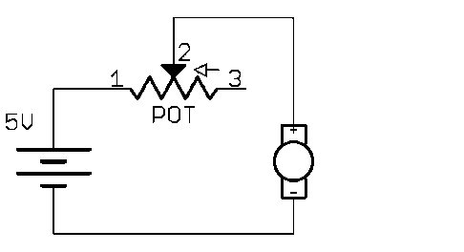

When you have the circuit working, try adding a red LED and 1kΩ resistor in parallel with the motor. The brightness of the LED will depend on the voltage across the motor (V\_M), which indicates the rotation speed of the motor.

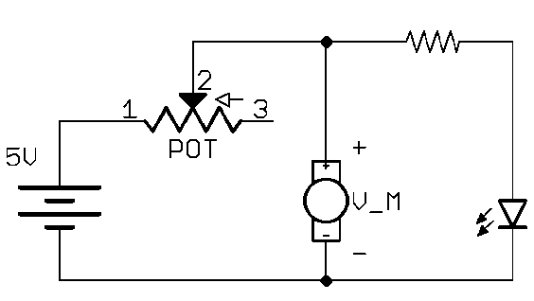

**Ask the students to consider:** How does the brightness of the light change with the motor speed?

Analog vs Digital Voltage Values (5 minutes)

How did the LED brightness change with the motor speed? A: When the motor is spinning faster, the LED is brighter.

Before today, have made an LED blink on and off with a button or Arduino.

When the LED switches between a limited number of values (such as on/off) we call these values digital values. This is how we were controlling the LED when we turned it on and off with the Arduino.

When the brightness can change smoothly between a continuous number of values, we call these analog values. This is how we were controlling the brightness of the LED today with the changing motor voltage.

Debrief Discussion (5 minutes)

**Encourage a discussion among the students for them to share their thoughts on the activity.**

Today we used a potentiometer to control the speed of a small vibrating DC motor. Why is this important? What applications does this have? Some possible answers include:

* DC motors can be used when we want to convert electricity into motion, such as making a fan. If you turn them around, they can also become electricity generators, such as in a wind or hydroelectricity plant.
* Vibrating motors can be used to give touch-feedback to devices, like in a mobile phone.
* Potentiometers can be used to control the current in a variety of circuits, including stereo amplifiers, and electric guitars.

What worked? What didn’t work? Why didn’t it work? What could we do next, or how could we make the circuit better?

Challenge and Explore

**If a student completes the lesson early, evaluate their understanding by asking them to try the following:**

* Why doesn’t the motor spin when the potentiometer is turned all the way to one side? A: the resistance is too high, so there is not enough current flowing through the motor to stop it from spinning.
* Can you add a switch to the circuit that controls both the motor and LED?
  + Skill: Building breadboard circuits
  + Skill: Understanding electricity (rock-slide analogy)  
    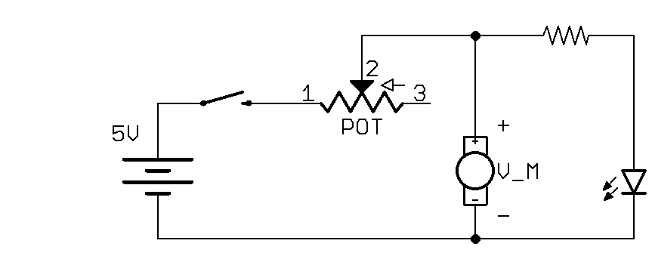
* Try wiring two motors so that they both turn on (excluding the potentiometer). Do they need to be wired in series or parallel? Why one and not the other?   
  A: they must be in parallel, because each motor needs at least 3V to turn on, so if we put two in series they would need 6V, and our battery only provides 5V.

*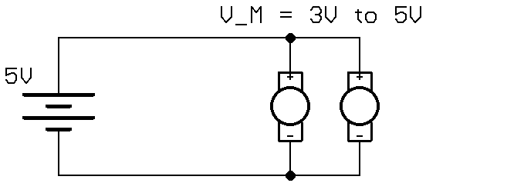*

Frequently Asked Questions

* Both my light and motor aren’t turning on. What’s wrong?  
  A1: Make sure the power supply is on and on the breadboard in the correct direction with the (-) from the power supply on the blue line of the breadboard:  
  CORRECT:  
  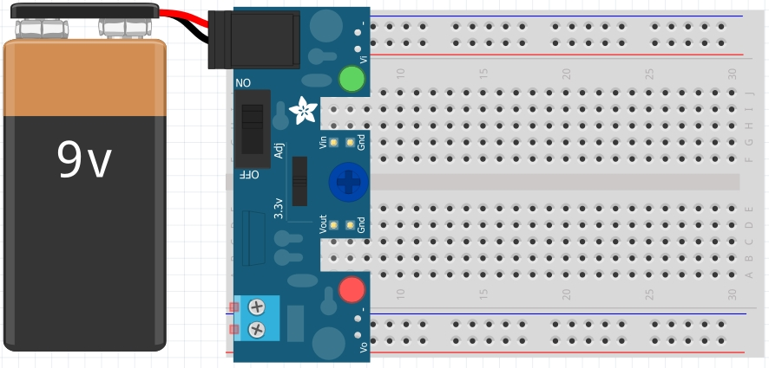  
  INCORRECT:  
  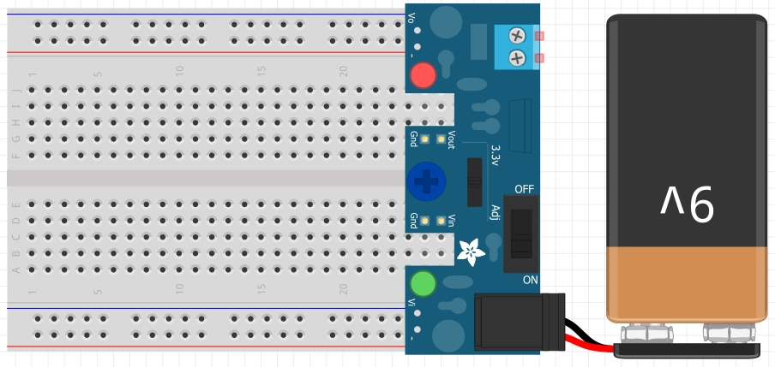

A2: Make sure that you’re connected to pins 1 and 2 OR pins 2 and 3 of the potentiometer. If you connect to pins 1 and 3, the resistance will always be at maximum (1 kΩ) and the circuit won’t get enough current to turn on.  
CORRECT:  
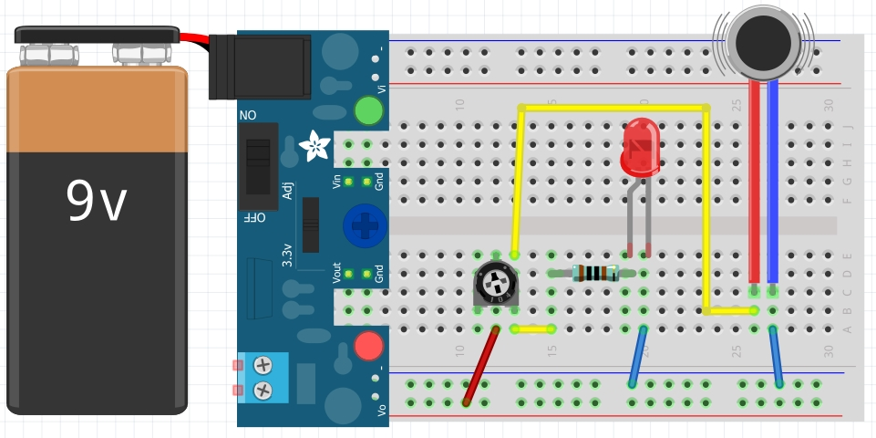  
INCORRECT:  
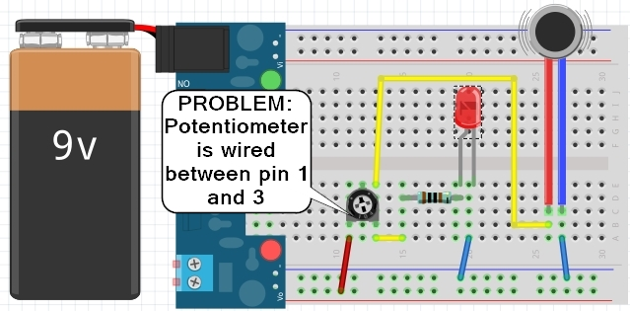

* The motor is turning on, but the LED isn’t. What’s wrong?  
  A1: check the polarity of the LED and make sure that the (+) side will is connected towards the (+) on the breadboard, and similarly for the (-) side.   
  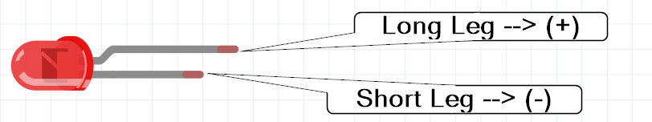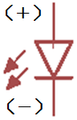  
  A2: check to make sure the LED isn’t burnt out by trying it in a friend’s circuit that is already working.

1. by lady ada from [Adafruit](https://learn.adafruit.com/assets/1087), CC-BY-SA-3.0 [↑](#footnote-ref-1)
2. Part images from Fritzing [↑](#footnote-ref-2)